Name : Kinza Saeed

Roll num : 00160400

Slot : 9 to 12 Sunday morning

**­Hackathon Day 3**

In this document I will discuss how to implement third party API in to

Sanity CMS and show data in the frontend with Next.js.

**API Integration**

For fetch api into sanity I followed some steps:

1. Make a folder in the project named with scripts and make file in the folder name

“importSanityData.mjs”



2. Write script for data integration

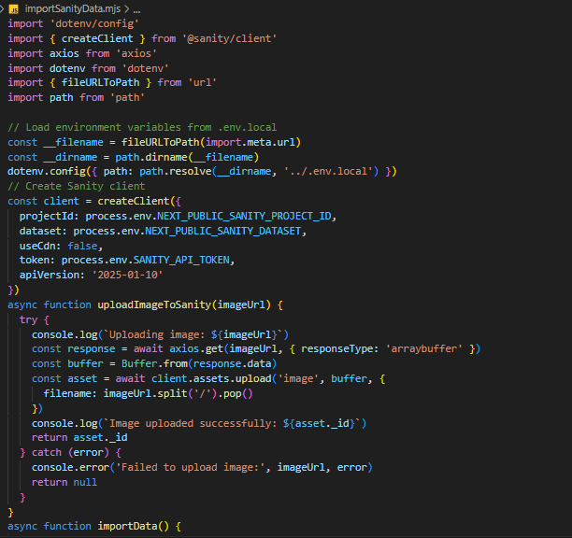

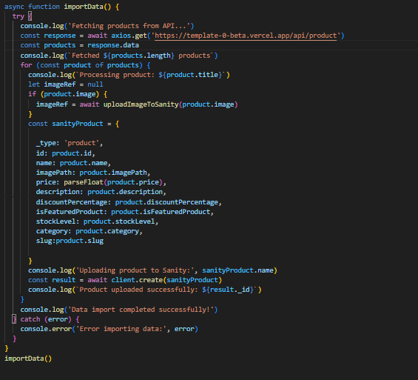

3. After writing script run command npm run import-data

To fetch data into sanity

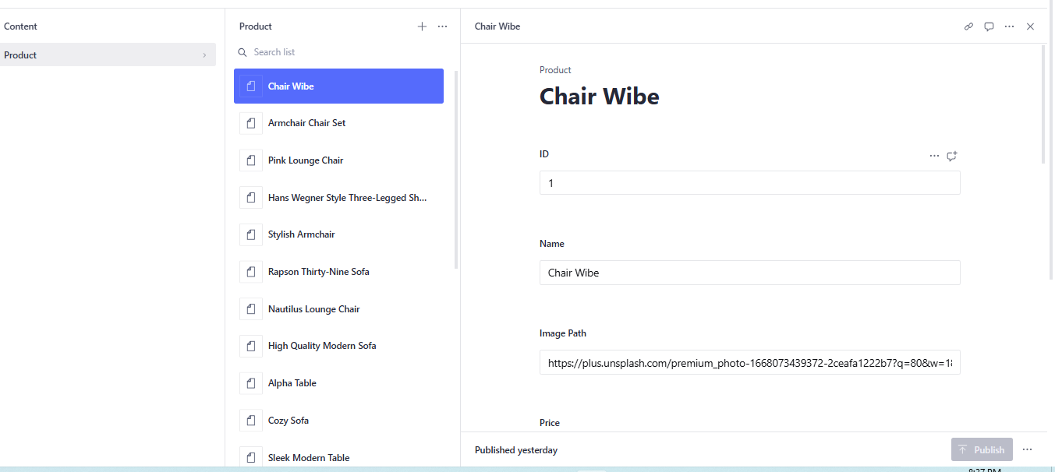

**Schema**

Define Sanity Schema

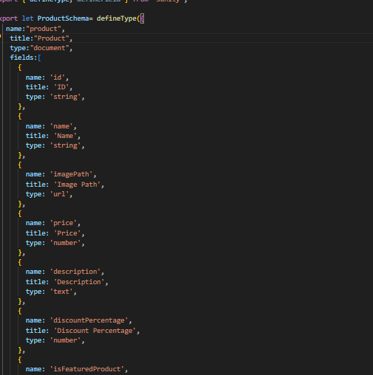

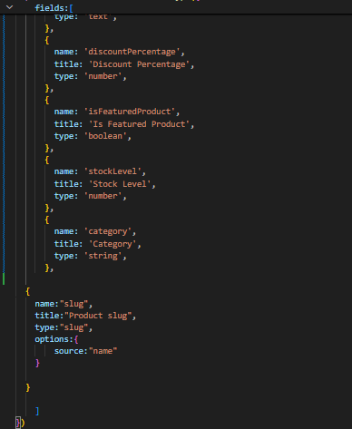

**Show Data at Frontend**

